Case Study Report: Ola Rides Analysis

# 1. Introduction

Ola, one of India’s leading ride-hailing companies, has transformed urban mobility by providing convenient and affordable ride options across cities. With millions of daily bookings, the platform has become an integral part of the transportation ecosystem. However, as demand continues to grow, understanding booking patterns, cancellations, and ride outcomes becomes essential for improving efficiency and customer experience.

# 2. Problem Statement

Ola faces challenges in ensuring high ride completion rates and maintaining customer satisfaction. Despite strong demand, a significant portion of bookings end in cancellations, either by customers or drivers. These cancellations not only reduce revenue growth but also weaken customer trust and retention. Furthermore, Ola needs deeper insights into peak demand hours, cancellation patterns across time, and the underlying reasons behind incomplete rides.

# 3. Objective

The objective of this analysis is to study Ola’s booking data to:  
- Measure ride completion versus cancellation rates.  
- Identify patterns in demand and peak booking hours.  
- Understand customer and driver cancellation behavior.  
- Provide actionable recommendations to improve ride completion, revenue growth, and customer satisfaction.

# 4. Key Business Questions

1. When does ride demand peak across hours of the day and days of the week?  
2. What % of rides are completed vs cancelled?  
3. Which ride categories (Mini, Sedan, Prime, Auto, Bike, etc.) are most popular?  
4. How much revenue is lost due to cancellations?  
5. What is the level of customer satisfaction with rides?

# 5. Dataset Description

The dataset used for this analysis was sourced from Kaggle. It contains booking information including:  
- booking_id – Unique booking identifier.

- booking_date_time – Date and time of booking.

- gender – Customer’s gender.

- month – Month of booking.

- day_of_week – Day on which booking occurred.

- t ime_of_day – Time slot of booking (morning/evening/night).

- distance_travelled – Trip distance (in km).

- time_taken – Trip duration (in minutes).

- Booking Status – Ride outcome (Completed/Cancelled/Incomplete).

- reason – Cancellation reason (if any).

- toll – Toll charges applied.

- category – Ride category (Micro, Mini, Prime, etc.).

- commission_base_cost – Ola’s commission on the ride.

- driver_base_cost – Base fare for driver.

- total_tax – Tax applied.

- total_trip_cost – Final trip fare.

- ratings – Customer feedback rating (1–5).

# 6. Methodology

Steps followed for analysis:  
1. Data Cleaning : Removed duplicates, handled missing values.  
2. Exploratory Data Analysis : Checked ride distribution by category, status, and time.  
3. Visualization : Created pivot tables/charts for ride status, revenue by category, and cancellation patterns.  
4. Key Business Questions : Addressed each question using data analysis.  
5. Methodology used : The methodology followed involved systematic observation of the data, deriving insights, and providing recommendations for each business question.

# 7. Analysis & Observations

# Most rides are booked between 9 PM to 12 AM, while demand is low from 5 AM to 8 PM. Weekday bookings (Tue–Fri) are higher than weekends.

# 67.2% of rides are completed successfully. Driver cancellations account for 19%, customer cancellations 7.7%, and 6% remain incomplete.

# Micro (2172 rides) and Mini (1965 rides) dominate bookings, while premium categories (Lux, SUV Rentals, Prime Rentals) have negligible demand.

# Successful rides generated ₹156,969 revenue. Revenue loss due to driver cancellations (₹45,444) is 2.5× higher than customer cancellations (₹18,496).

# Customer satisfaction is relatively high, with most ratings at 4⭐ (1631) and 5⭐ (1549). However, ~19% riders gave low ratings (1⭐ or 2⭐).

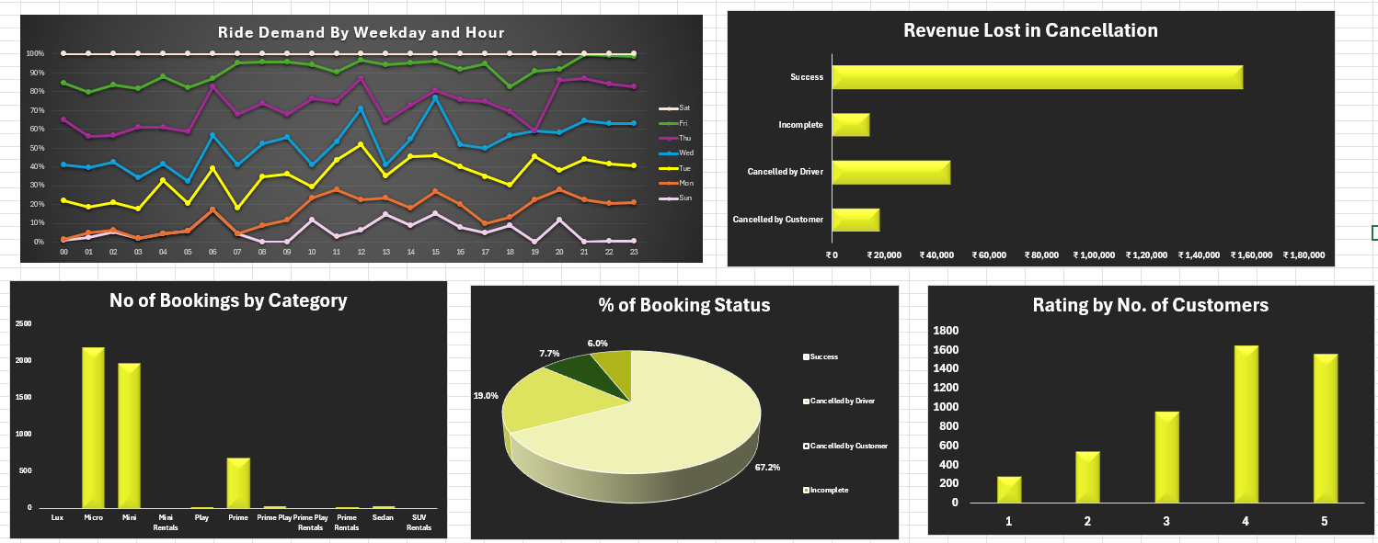

# 8. Insights

# Ride demand peaks in the evenings (9–12 PM), suggesting that work-related commuting is the primary driver of usage.

# Driver cancellations are the single largest source of unreliability, leading to revenue loss and weakening customer trust.

# Micro & Mini categories are overwhelmingly preferred, showing that customers are highly price-sensitive.

# Although most ratings are positive, low-rated rides indicate recurring service issues that need to be fixed to prevent churn.

# 9. Recommendations

* Expand Micro & Mini fleets and ensure higher driver availability during peak hours to meet demand.
* Introduce stricter cancellation policies (penalties for frequent driver cancellations) and offer incentives for reliable drivers.
* Promote premium categories with targeted offers (first-ride discounts, comfort perks) and better awareness campaigns.
* Investigate low-rated rides, address recurring issues (delays, driver behavior, vehicle quality), and reward high-rated drivers to improve satisfaction..

# 10. Conclusion

Ola continues to experience strong ride demand, particularly in evening hours, but faces challenges with high driver cancellations and low adoption of premium categories. These issues not only reduce revenue but also risk customer trust. By strengthening driver reliability, expanding high-demand categories, and addressing customer concerns, Ola can enhance both profitability and long-term rider satisfaction

.